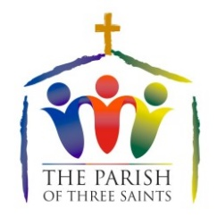
Worship
for June - July 2021
Information and links can be found at
www.theparishofthreesaints.org.uk

Date | In Church |  | Online
June
6th First Sunday after Trinity | 10am Eucharist  St Mary’s, East Brent
13th | 10am Eucharist  St Michael’s, Brent Knoll |  | Reading, Prayer and Reflection
20th | 10am Eucharist  St Christopher’s, Lympsham
27th | 10am Eucharist with Baptism  St Mary’s, East Brent
July
4th | 10am Eucharist  St Michael’s, Brent Knoll
11th | 10am Eucharist  St Christopher’s, Lympsham |  | Reading, Prayer and Reflection
18th | 8am BCP Holy Communion  St Christopher’s | 10am Eucharist St Mary’s, East Brent
25th  James, The Apostle | 10am Eucharist St Michael’s, Brent Knoll | 4pm Picnic/First Church venue tba

Please go to
www.theparishofthreesaints.org.uk
for latest information and any updates

Revd Kevin Wright 01278 760844

